**How to access Canvas at home:**

1. Go to <https://www.paulding.k12.ga.us/>

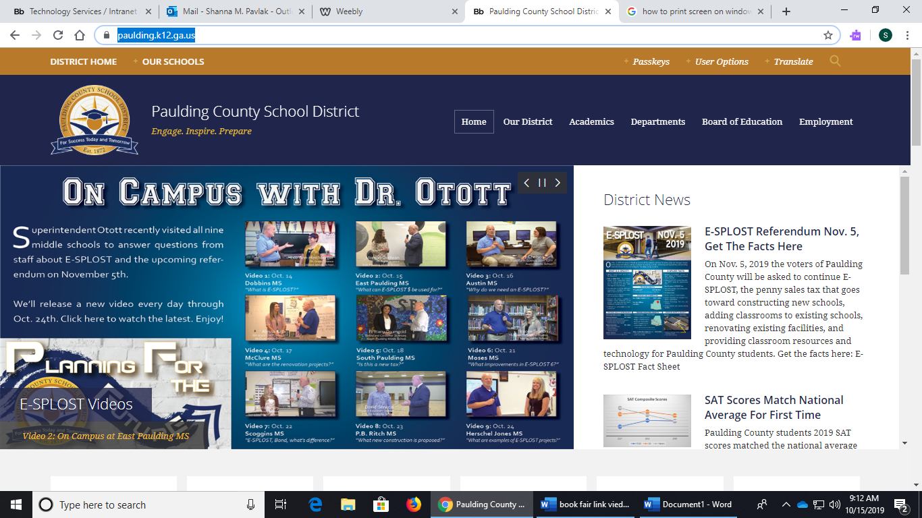

1. Scroll down. Click on Student Dashboard.

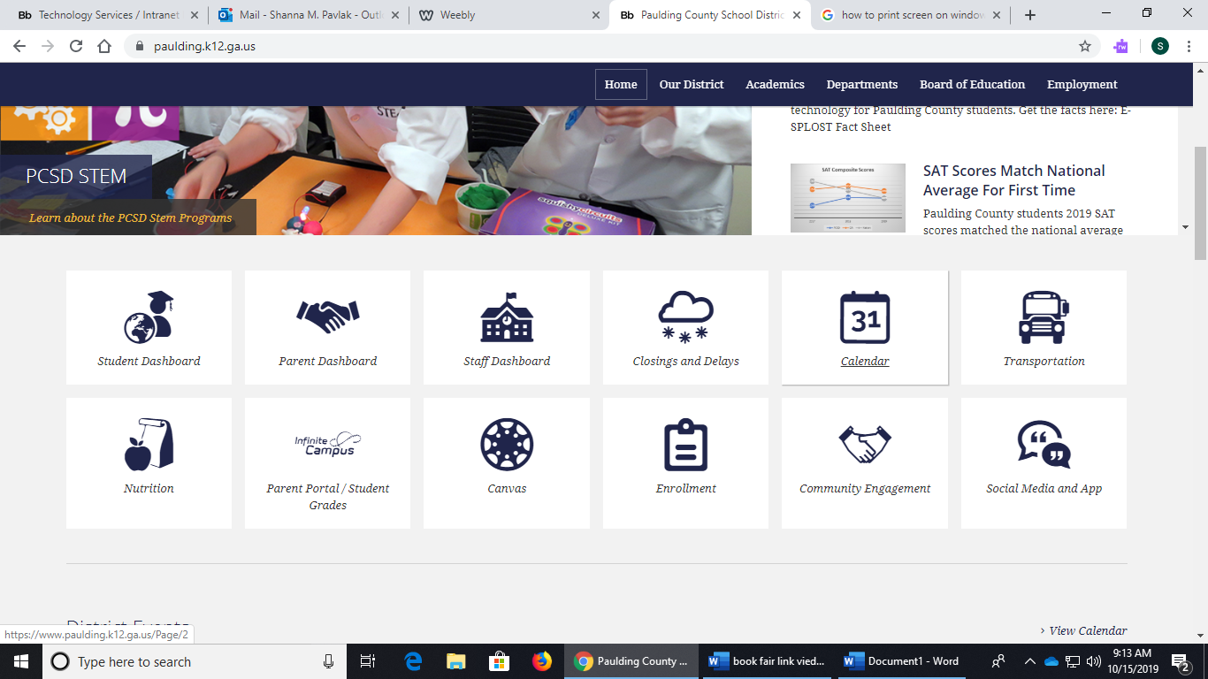

1. Click on Elementary Dashboard

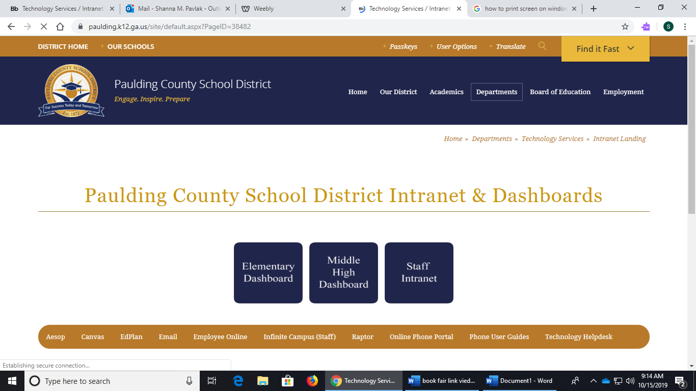

1. Click on the Red C button. It should be the first icon on the dashboard.

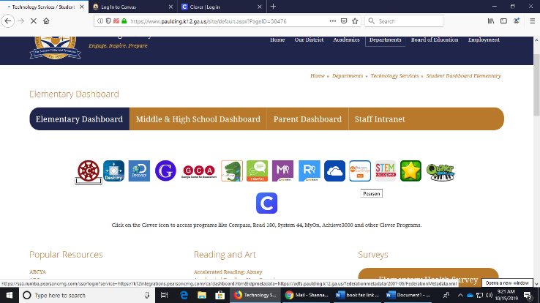

1. You will be asked to login to Canvas with your student’s login information for the computers at school. The Username is your student’s lunch number. The password is their first, middle, and last initial, followed by the student’s month and date of birth. The password is all lowercase and no spaces. For example, jdd0505. If you are unsure of your student’s login information, please contact your student’s teacher on Class Dojo.

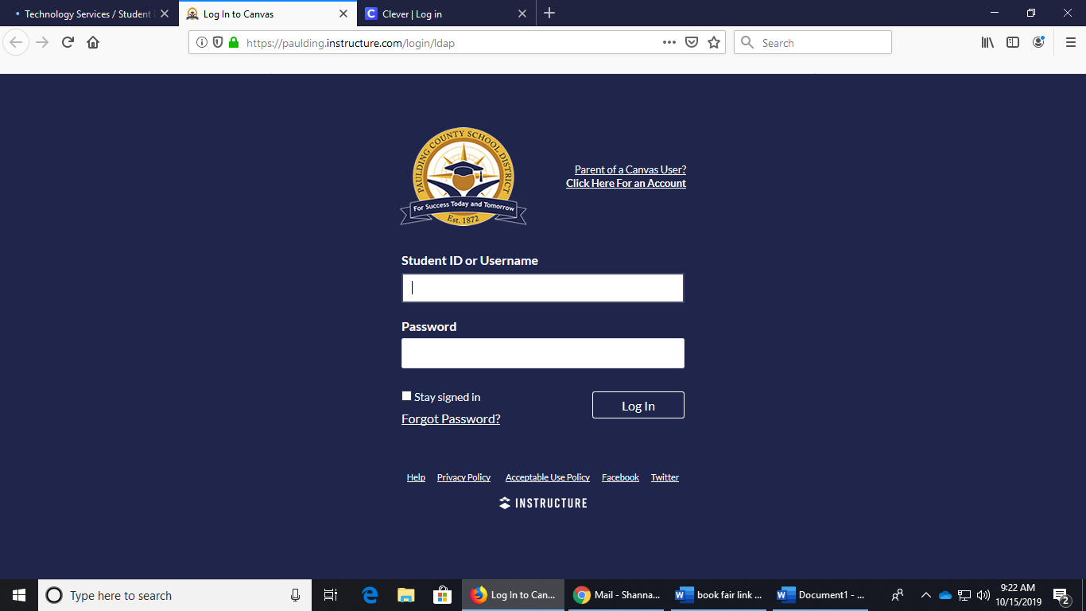

1. Once you have logged in, you should be able to see information about what your teacher wants your student to complete on the dashboard.

